**MULTIPLEXING**

Transmission medium have varying data carrying capacities. To make full utilization of transmission medium capacity, computer networks use separate channels that allow sharing of a single physical connection for multiple communication. Multiple carrier signals are transmitted over the same medium at the same time and without interfering from each other. So, **Multiplexing** is the process of combining multiple signals into one signal, over a shared medium. As demonstrated below.

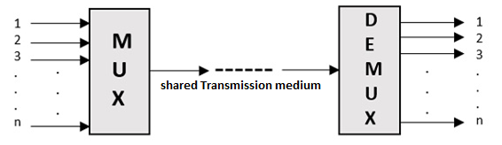

Multiplexing was first developed in telephony. A number of signals were combined to send through a single cable. The process of multiplexing divides a communication channel into several number of logical channels, allotting each one for a different message signal or a data stream to be transferred. The device that does multiplexing, can be called as a **MUX.**

The reverse process is called Demultiplexing, it is a technique of separating the merged signals and sending them to the corresponding receivers. It is also called as **DEMUX**.

The two basic multiplexing techniques are— Frequency Division Multiplexing (FDM) and Wavelength Division Multiplexing (WDM).

**Types of Multiplexers**

There are mainly two types of multiplexers, namely analog and digital. They are further divided into FDM, WDM, and TDM. The following figure gives a detailed idea about this classification. However, our course is confined to two basic multiplexing techniques namely Frequency Division Multiplexing (FDM) and Wavelength Division Multiplexing (WDM).

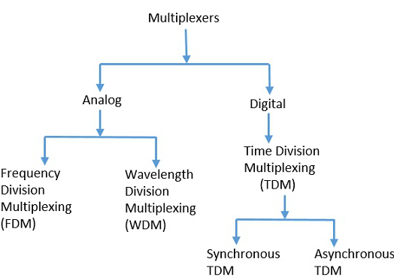

**FDM**

FDM involves electromagnetic spectrum below light. In FDM it combines different carrier frequencies signals into a single signal of higher bandwidth. The bandwidth of the communication medium link carrying the combined signal is greater than the sum of the bandwidth of the individual signals that are combined. FDM is used for high band—width analog Transmission systems like broadband technology.

FDM Concept:-

In FDM, the total bandwidth is divided to a set of frequency bands that do not overlap. Each of these bands is a carrier of a different signal that is generated and modulated by one of the sending devices. The frequency bands are separated from one another by strips of unused frequencies called the guard bands, to prevent overlapping of signals.

The modulated signals are combined together using a multiplexer (MUX) in the sending end. The combined signal is transmitted over the communication channel, thus allowing multiple independent data streams to be transmitted simultaneously. At the receiving end, the individual signals are extracted from the combined signal by the process of demultiplexing (DEMUX).

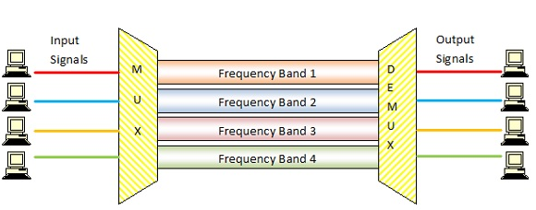

For Example: if the frequency bands are of 150 KHz bandwidth separated by 10KHz guard bands, then the bandwidth capacity of the communication channel should be at least 630 KHz (channels : 150 × 4 + guard bands : 10 × 3).

**WDM**

WDM is similar to FDM it involves light signals, which uses very high frequencies. It is an analog multiplexing technique, in which multiple optical carrier signals are transmitted in single light spectrum with varying the wavelengths. It also enables bi-directional communications over one strand of fiber. If the wavelength increases, the frequency of the signal decreases.

WDM Concept:

In WDM, the optical signals from different sources or (transponders) are combined by a multiplexer, which is essentially an optical combiner. They are combined so that their wavelengths are different.

The combined signal is transmitted via a single optical fiber strand. At the receiving end, a demultiplexer splits the incoming beam into its components and each of the beams is send to the corresponding receivers.

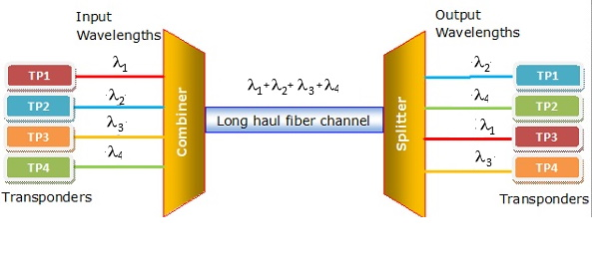

Here It has 4 optical signals of 4 different wavelengths. Each of the four senders generates data streams of a particular wavelength. The optical combiner multiplexes the signals and transmits them over a single long-haul fiber channel. At the receiving end, the splitter demultiplexes the signal into the original 4 data streams.